Applying linear relationships

In-class investigation Solutions and marking key
Question 1
(a) Solution
Total payments
 | Number of hours
Plan | 2 | 3 | 4 | 5 | 6
A | $40 | $60 | $80 | $100 | $120
B | $46 | $64 | $82 | $100 | $118
C | $47 | $63 | $79 | $95 | $111

Marking key/mathematical behaviours | Marks
- Calculates total payments for each of the three options  - Accuracy throughout | 3  1

Question 1
 | Solution | Marking key/mathematical behaviours | Marks
(b) | The hourly rate is constant  The payments increase by a constant amount as the hours increase by 1 | - Refers to hourly rate in first table  - Refers to increase in second table | 1  1

Question 2
 | Solution | Marking key/mathematical behaviours | Marks
(a)  (b)  (c) |  | - Uses variables provided  - Formats rule correctly  - Identifies hourly rate for all tables  - Identifies constants in all tables | 1  1  2  2

Question 3
 | Solution | Marking key/mathematical behaviours | Marks
(a) | Number of hours of child minding  Plan 2 4 5  D $60 $120 $150  E $60 $110 $135  F $60 $100 $120 | - Reads payment for 2 hrs  - Reads payment for 4 hrs  - Reads payment for 5 hrs | 1  1  1
(b) | (i) 0 (ii) 10 (iii) 20 | - Reads y-intercept | 3
(c) | D has the steepest line | - Links gradient to rate | 1
(d) | Intersect at the same point | - Identifies intersection as point of equality | 1
Question 4
 | Solution | Marking key/mathematical behaviours | Marks
(a) | $20 | - Use data from various sources to identify largest value | 1
(b) | 0 | - Use data from various sources to identify least value | 1
(c) | $30 | - Use data from various sources to identify largest value | 1
(d) | $15 | - Use data from various sources to identify least value | 1

Question 5
 | Solution | Marking key/mathematical behaviours | Marks
 | (i) W and Y  (ii) Z  (iii) Y  (iv) X and Z  (v) A (and D) | - Identifies same gradient  - Identifies lack linearity  - Reads graph to determine value  - Read graph to determine values  - Identifies 0 as vertical intercept | 1  1  1  2  2

Question 6

 | Solution | Marking key/mathematical behaviours | Marks
(a) | Rule to calculate payment Payment for 5 hours work  K=10r + 10 $60  K=15r + 10 $85  K=20r + 25 $125  K=25r + 30 $155 | - Uses variables given  - Identifies constant  - Identifies hourly rate  - Presents formula correctly  - Uses formulae to determines payments  - Presents values with $ | 1  1  1  1  1  1
(c) | Joel $170  Billy $30  Brooke $130 | - Uses correct rule from table  - Uses correct rule from table  - Uses correct rule from table | 1  1  1
(d) | Billy: Total of 7 hours on 3 different nights = $100  Brooke: 3 nights of 4 hours = $390  Joel does 6 nights, each of 3 hours = $510 | - Total adds to $1000  - Indicates number of petrol allowances  - Indicates number of hours  - Correct scheduling for each person | 1  1  1  1

Question 6 (b)
Solution
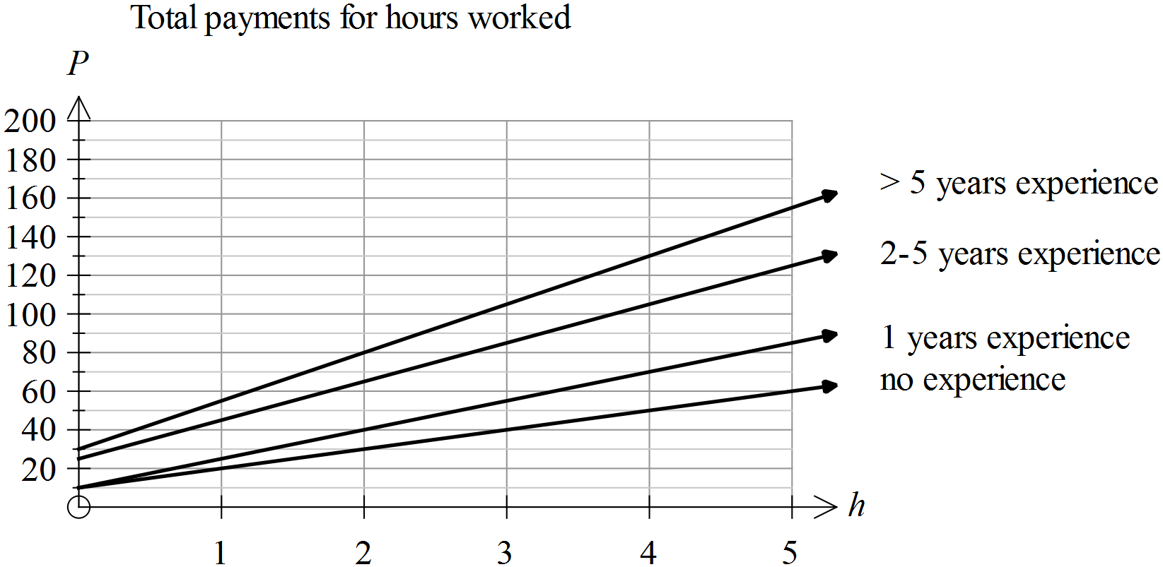

Marking key/mathematical behaviours | Marks
- Places correct scale on both axes  - Selects appropriate title  - Correctly plots P when h = 5  - Correctly plots petrol allowance  - Draws line between points  - Labels each graph | 1  1  1  1  1  1  1

